Levels of Acoustic Registration
Prepared by Kenneth Bozeman

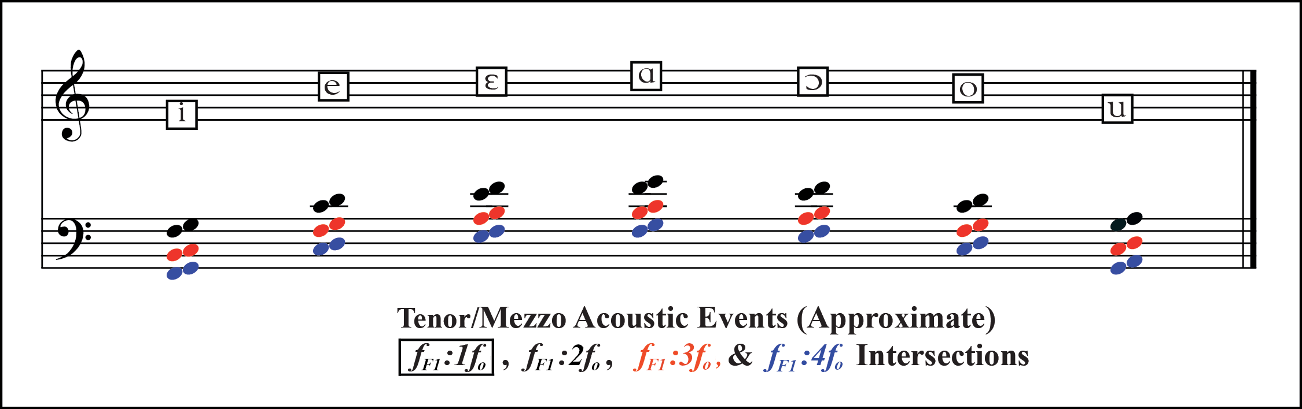

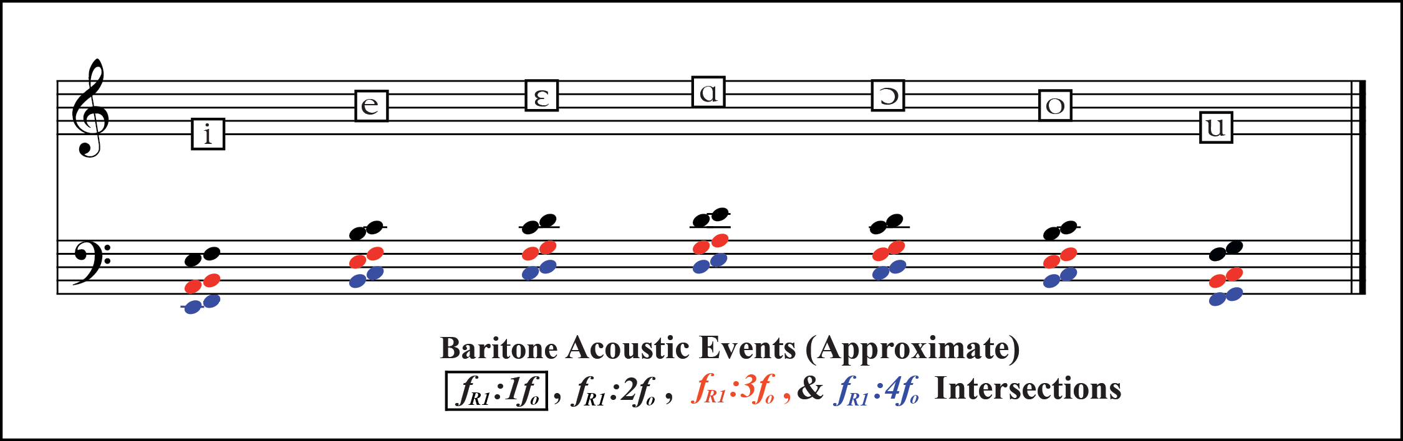

Whoop Timbre: Sung pitches that match the first formant IPA boxes on the treble clef are in whoop timbre. The vocal tract resonances that are generating those first formant locations will need to track the sung pitch higher to maintain whoop timbre. This is done by vowel opening. Whoop timbre is fundamental dominant, and sounds like “head” voice.
Close Timbre: Sung pitches between the first formant boxes and the black “pitches of turning” an octave below are in close timbre.
Pitches of Turning: the black pitches indicate the transition pitches between open and close timbre—sung pitches above them are in close, sung pitches below them are in open for the indicated vowel.
Open Timbre: Sung pitches below the black pitches of turning are in open timbre.
Levels of Open Timbre: sung pitches below the red pitches open further, and below the blue pitches open even more. Increasing openness of timbre increases auditory roughness (buzziness).
General Principle: The more harmonics there are below the first formant, the more open the timbre will be. One harmonic below F1 is close timbre (pitches within an octave below the first formant); two harmonics below F1 is open timbre (pitches more than one octave below the first formant); three is more open, four more open yet, etc.

