Week 2 Assignment
You are welcome to work in groups on this assignment, except for the first two questions.
- Where are you? Pick a location and find daily data for number of CoVID-19 cases. Plot the data with t = 1 being the first day where your locatlity had at least 10 cumulative cases. Fit a trend to this data and report your best results in a regression table. Use these estimates to project the number of total cases on May 1 and June 1.
Some suggestions:
- Regress cases on t, on t and t²;
- Regress cases on t, t², add a dummy for when locality put restrictive measures in place
- Take natural log of cases and regress that on t
You are welcome to work with your group on this, but report your own results.

- Who did you explain this graph to? What challenges did you have explaining it? What questions did they have for you? Do you think they could explain it to someone else?

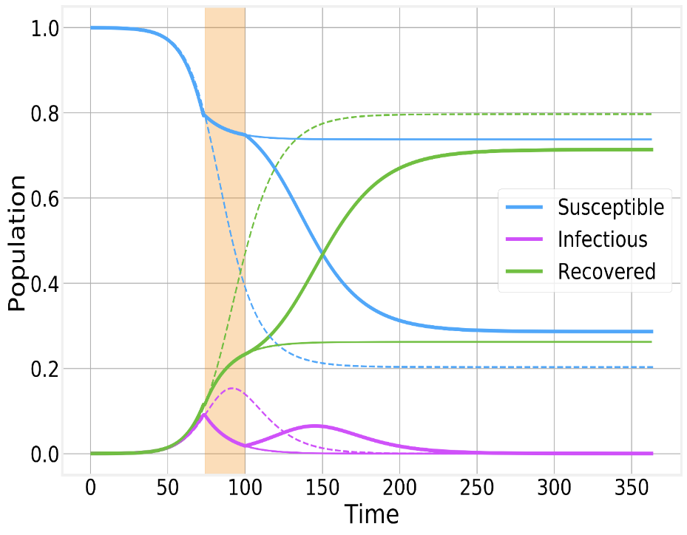
Figure 1: Three Eras of the Epidemic
There are three discrete periods represented in this slide. For t = 1 to t = 75, the disease is unconstrained (and the dotted line represents the trajectory if the disease remains unconstrained, with R 0.8). From 75 < t < 100 there is hard suppression, with the lighter solid line representing the trajectory if that containment remains in place. For t > 100, containment lapses, and there is another round of infections, with R 0.7 and S 0.3.
- What time series does the number of cases represent in the graph above? If it doesn’t neatly fit any of the series, suggest a way of plotting the number of cases in your graph.
Ferguson et al. (2020)
- Figure 1 (see previous page) shows a 25-day period of effective suppression. What are the benefits associated with suppression? Does Figure 1 reveal any of those benefits?

- Ferguson et al refer to “optimal mitigation policies,” which implies there is an objective function (i.e., a constrained maximization problem). Do Ferguson and his colleagues identify an objective function? Suppose you wanted to write down a nice twice differentiable objective function for this problem. What is your objective? What are your constraints? What are the key tradeoffs? For example, are we trading off lives saved with lost income, as some suggest? This is kind of an involved question.

- Are mitigation and suppression policies substitutes or complements?

- What is “time consistency”? What is the “epidemic yo yo”?

- Do you think R_{t} is the same in t = 1 to t = 75 as t > 100? Explain.

This is only a Test
- For people with an I-E concentration: Who is Paul Romer? What have you read of his?

- Looking at Romer’s Summary Data from 50 Runs of the Model:
  - At what percentage of the population does I_{t} max out?
  - What do you think the value of R₀ is? What is the range of possible values for R₀?
  - Compare Romer’s implied R₀ with what we saw in Goncalves (the slides from 4/9)

- What is the principal benefit of implementing testing?

- How accurate does testing need to be to generate these benefits? What are you basing your answer on? What is the intuition behind your answer?

- Summarize the IGM Forum polls and comments on testing. What stands out to you?

And the Rest
- What is the thesis of Twilley’s paper? What surprised or confused you? (the number of things that surprised or confused you should equal the number of people in your group; if you resolved some confusion amongst yourselves you can describe that here).

